11/01
-
- Look for constructs already available as measures.
  - Identify multiple gaps and then pick one based on the measures
- Study methods
  - Literature Study
  - Quantitative Analysis
  - Qualitative Analysis
- CBIB (Community based Internal branding)
  - Google Scholar - (“Internal Advertising” or “Internal Branding”) and “Brand Communication” [be specific on what you are looking for and put words in quotes for efficient results)
  - Filter to specific language, region, location (filtering will help in drilling down to a particular paper)
  - Very important to cite/ quote in a research paper -> that shows data is validated otherwise its a game of assumption. The best way is to find literature surveys of the paper and related sources of it.
- Validity
  - Internal
    - Survey is more , Experimental is less
    - Refers to whether the manipulation of the independent variables or treatments actually caused the observed effects of the dependent variables.
    - Control of extraneous variables is a necessary condition for establishing internal validity
  - External
    - Survey is less, Experimental is more
    - Refers to whether the cause and effect relationship found in the experiment can be generalized.
    - To what population, settings, times, independent variables and dependent variables can the results be projected?
  - Measurement strategy
    - Constructs & Scale
      - If a scale exists, use it else create one by conducting experiments (control and experimental groups)
- Check out journal papers and what journals are getting approved
  - Read abstract of those papers
    - Find the type of research being currently done,
      - analyze the word cloud (prefer words are on the periphery, not in the center as 3-4 yrs from now, those words wouldn’t be relevant anymore)
- Term Paper (~Feb; Quantitative Analysis)

12/06
- For Thesis and Research
- opt for deductive (preferably). Inductive would be explanatory requiring alot of time and research to devise a theory on the data being available
- It also aligns well with the mental model of cloning a proven theory and validating/ testing it.
- 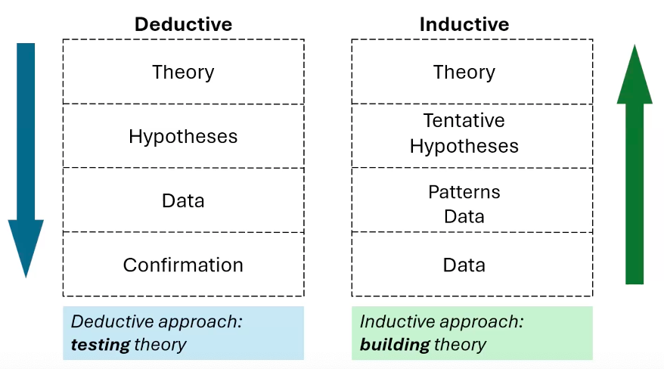
- SPSS Tool installation
- When presenting your equation for discussion - you can quote Cohen to demonstrate the significance of the dependent variables.
  - Weak impact - 0 - 0.2
  - Medium impact - 0.2 -0.5
  - High Impact - >0.5
- Std. Deviation is a better measurability of data dispersion. Not range of the data
- Important to have predictor variables on the same scale. Z scale is a good measure to have the variables at the same scale else you'll have a bias equation where one variable will be more impactful than other due to the range.
  - For financial modeling, there are different kind of scales utilized since the data is not linear. Logarithmic scales/ Geometric means. eg. Financial Modeling
- Degrees of Freedom - In statistics, when estimating - anything is calculated by fixating one value in the equation.
- Example Model -
  - https://docs.google.com/document/d/1cYvWu2XkVR_klJNXqq2zozpeFNlW3zEH43jlY6y3HTc/edit?usp=sharing
- 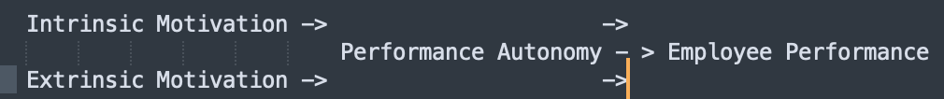

- Motivation-Performance Survey Form (Academic Survey) -
- https://forms.gle/26HMHwMqmWk2q9Ab8
  - Timing of the survey is very critical to make sure the responses are not biased. Impact of Seasonalitity.eg. After appraisal, the responses will be very different than before. Hence timing it in such a way should not impact the responses.
- ** Action Item - Build your own model and survey form on the finalized thesis topic.
- - Try to incorporate "Zombie Seat Hunter" Idea into the thesis topic for real world use case(since you are already working on it)

12/22
- Literature review would consume 80% of one’s time in Research.
- A sound literature review is the key
  - Build/propose your model
  - Identify the constructs(check if there are established constructs for you topic by referencing similar prior research)
  - Find measurement scales (check if prior thesis exist and measurement scales have been defined)
  - If above develops to be a survey, develop questionnaire
- Inclass Working Session - Downloaded the form inputs as an Excel file and performed data transformation(cleaning, encoding, eliminating etc) on it (Build your own model using ‘Zombie Seat Hunter’ Research Idea)
  - Recorded Session - Pwd : @c8b^m77
- Data Collection
  - Missing Data
    - First check MIssing Completely at Random (MCAR) by conducting t-test for missing and present values for every variable (passes if > 0.05)
    - If t-test fails, check Missing at Random (MAR) by doing logistic/ linear regression (depending on whether it is a categorical/linear variable) checking for p-values between variables (passes if > 0.05; if below then MNAR)
    - If Missing Not At Random (MNAR) - change the research design
  - 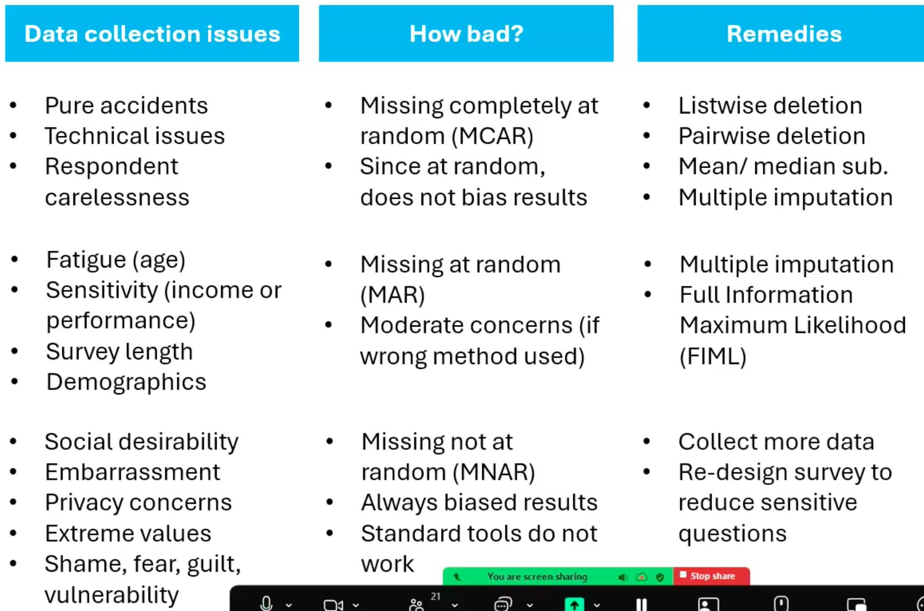
01/16:
-
- The distribution of sample mean
  - T : concept - if total data points 1000, take 30 at random and calc their means, repeat that for 500 times and you can plot a t graph with 500 means
    - Increasing sample size usually resolves most issues with distribution (Central Limit Theorem)
    - If sample size is very high, then chances of power (1 - Beta) being high is very low
    - Sample size (n) = (Z1 - a/2 + Z1 - b)square/ d-square

  - Z
  - F : Conduct F test when there are more than 2 categories/ groups in a variable. It helps identify which group is different. T is helpful when 2 groups.
  - X-square
- Type 1 error (Alpha) - when you reject status qou (null hypothesis) & Type 2 error (Beta) - when you fail to reject alternative hypothesis
  - As Alpha reduces, Beta increases.
    - 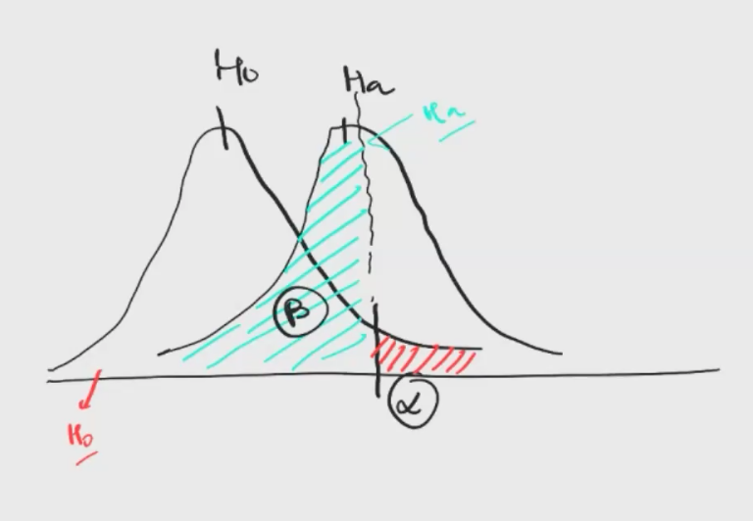
    - Alpha is in Null hypothesis, Beta is in Alternate hypothesis
    - Effect is the slope. (y = mx+c) Effect is “m”
    - Power of test(1 - Beta) is you are challenging the status quo and are statistically proving it right
      - 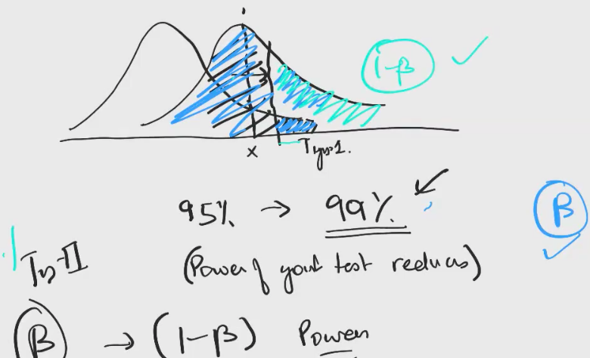
    - Generally, alpha is <= 0.05, power is 80% and sample size is around 200-400
      - There should be sufficient points for different groups (eg. Male, Female). You’ll observe this when there is polarity in recorded points between the two groups. Polarity is when one group’s mean is 3 and other groups 8 on a scale of 1 to 10.
- Hypothesis Testing
  - Be mindful of wordings used. (eg. instead of Accept, use ‘Fail to Reject’): reason being, the results may/ may not be accepted outside of your scope of analysis but within your scope of analysis, we know definitely that its failed to reject.
  - Type 1 error accepted by journals if it falls within <0.05 range (ie. 95% confidence)
- Steps when checking distribution
  - Set Up Alpha upfront (ie 0.05)
  - Set up acceptability probability region
  - Perform Hypothesis testing

